ASSIGNMENT-3(solutions)

Create an Interactive Dashboard

This supermarket sales dashboard which shows how much stock is sold in different perspectives.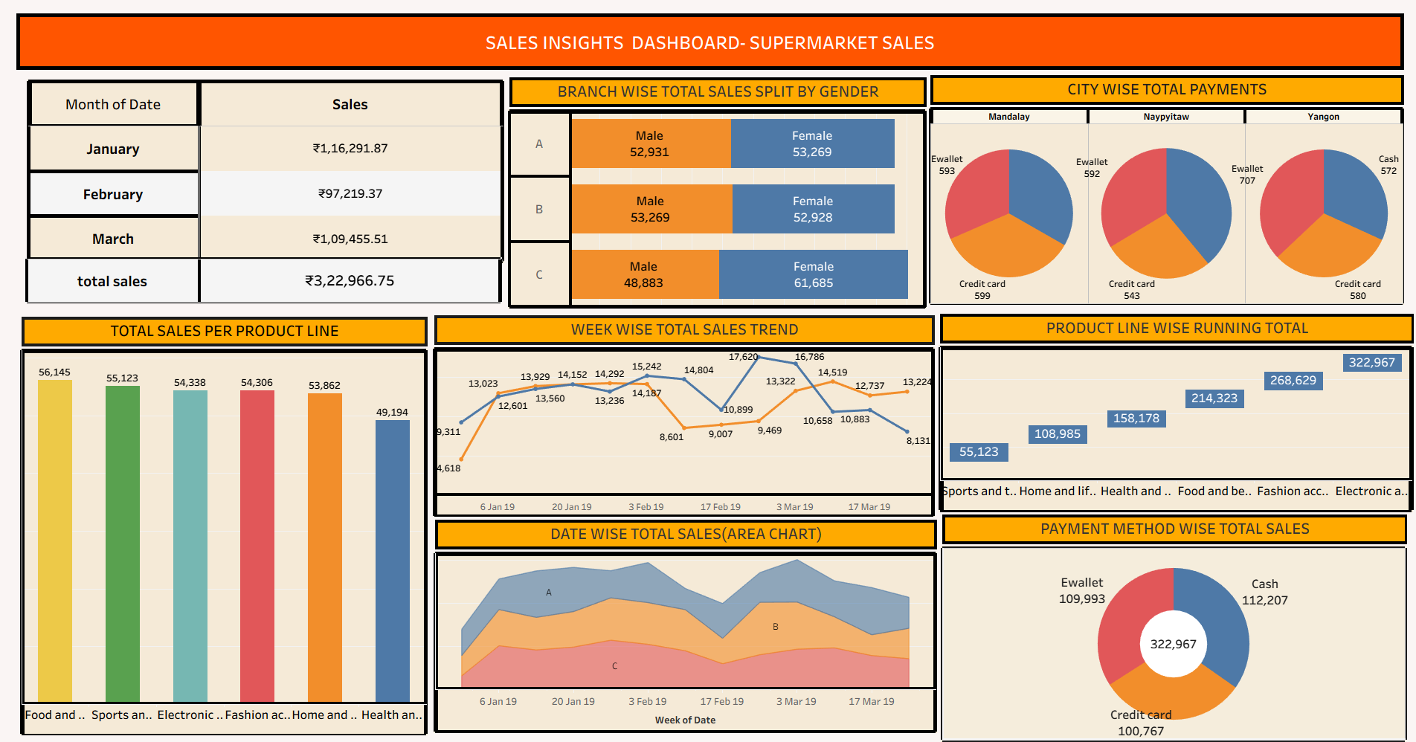This dashboard is made up with filters so that we can see the insights if we change any small data